Elders Are Abused In SNFs But The Data Proving It Isn’t Helping
By Holly Barker

It’s not about the money. Skilled Nursing Facilities account for a relatively small portion of total Medicare expenditures based on published CMS data.

It’s about who SNFs serve and how.

SNFs (pronounced like “sniffs”) provide rehabilitative and therapeutic inpatient care to people after the hospital discharges them, but before they are well enough to return home. Medicare usually covers the benefit for up to 100 days, but many people need to recover longer.

SNF patients are, by definition, in need of ongoing medical assistance delivered by trained professionals. They have to be to qualify for the Medicare benefit.

They are also almost always much older – usually over 70 years old, according to HHS data.

In other words, these are vulnerable people.

HHS has long recognizing the risks Medicare beneficiaries face as an aging population. It’s in part why regulations require SNFs and other suppliers and providers participating in Medicare to comply with certain regulatory conditions designed to protect seniors and ensure quality of care.

But 100% compliance with the extensive regulations governing SNFs and many other Medicare providers is not enforced. It’s well understood by industry and law enforcement alike that thousands of SNFs continue to operate while breaking at least some of the rules. We know because we have the CMS survey data to back it up.
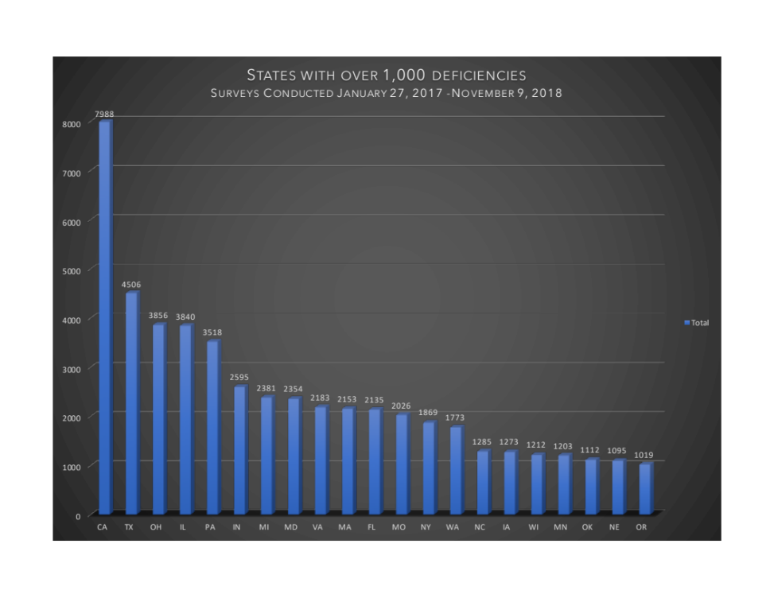

In order to participate in Medicare, CMS requires SNFs to allow it to conduct regulatory surveys, which include site visits, record reviews, and interviews with patients and staff.

The surveys, which are unannounced, are often routine but can be initiated as a result of specific complaints about a SNFs services.

When a SNF is non-compliant with a requirement, survey inspectors may identify what’s referred to as a ‘deficiency.’

Survey findings are extensively documented. If there are adverse findings, the SNF must typically develop a corrective action plan and demonstrate effective implementation to resolve the non-compliance.

Recent Data

From January 27, 2017 through November 9, 2018, Medicare contractors performed over 4,000 surveys of SNFs across the United States. On average, those facilities received 14 deficiencies per survey. In some states, the average was much higher.

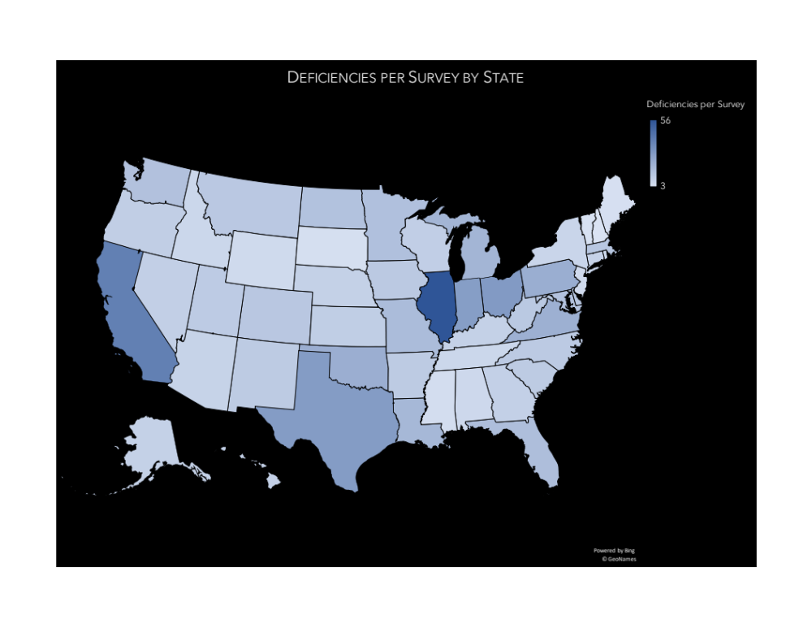
Illinois was the farthest outlier with an average of 56 deficiencies per survey. California came in second at 40. Ohio and Texas were tied for number three with an average of 30 deficiencies.
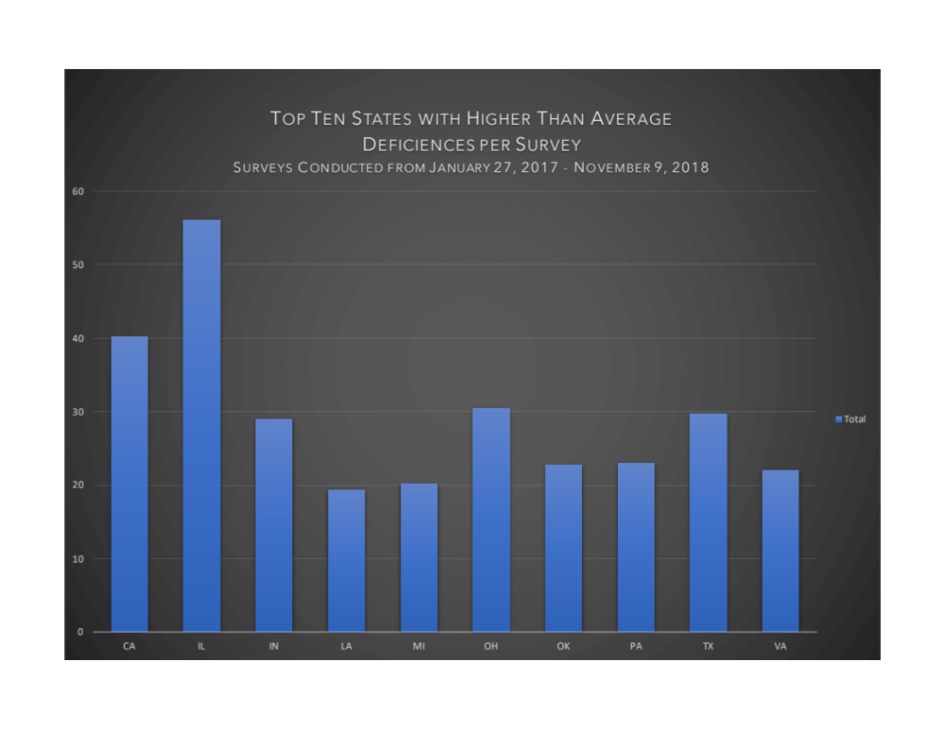

The most commonly cited deficiency, accounting for 5% of the total deficiencies issued across all of the surveys, was failing to “provide and implement an infection prevention and control program.”

The second most common deficiency, accounting for about 4.6%, related to food handling and storage.

Quality not Quantity

While the number of deficiencies cited during a survey is relevant to assessing a SNF’s quality of care, not all deficiencies are equally problematic.

When surveyors identify a deficiency, they assign a letter “tag,” which essentially labels the degree of harm (no actual harm, potential minimal harm, actual harm, and immediate jeopardy to patient safety) and its scale (whether the conduct was isolated, part of a pattern or widespread).

Level 1 tags are issued for low-risk deficiencies when there is no actual patient harm. At the opposite end of the spectrum are Level 4 tags, which are issued when the surveyor finds “immediate jeopardy to resident health or safety.”

Tags are further categorized to help administrators determine the appropriate legal remedy. As the harmful impact and scale of the deficiency increases, so does the applicable remedy. A SNF that has Level 1 tags can still be considered “substantially compliant.” For Level 4 tags, however, CMS must terminate the provider’s participation in Medicare within 23 days of the finding, unless the SNF is able to correct the deficiency in that window.

Because most SNFs rely on Medicare for revenue, provider termination can mean the end of a facility’s financial viability.

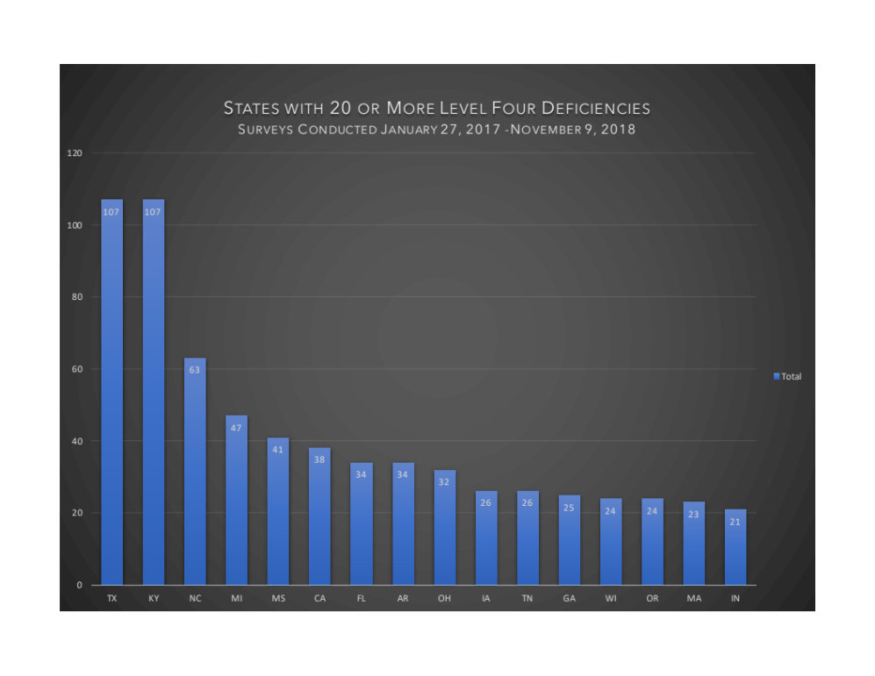
There were altogether 887 Level Four deficiencies issued during the 23-month time period between January 2017 and November 2018. Five states accounted for more than half of them, but Texas and Kentucky stood out with 107 Level Four deficiencies each.
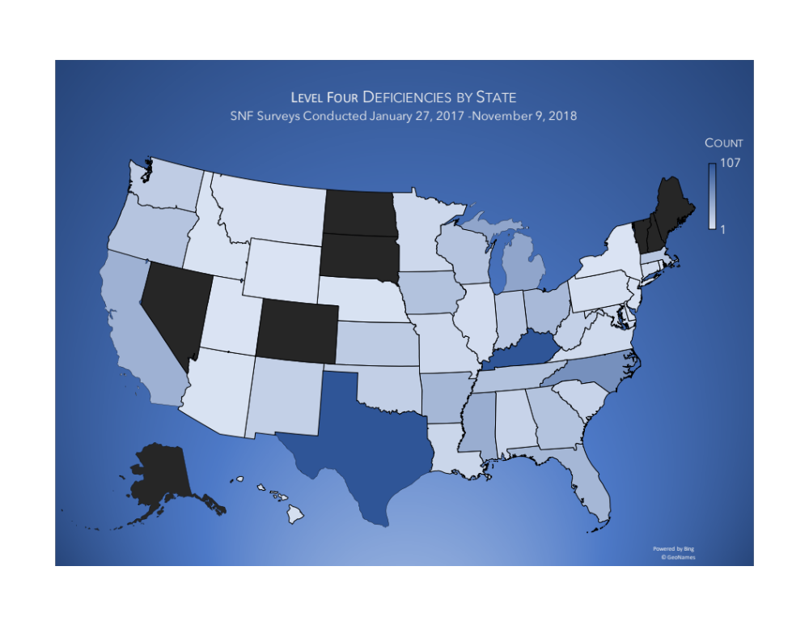
Just two types deficiencies accounted for one-third of the total Level 4 deficiencies issued. The first requires SNFs to ensure “the facility is free from accident hazards and provides adequate supervision to prevent accidents.”

The second requires the SNF to “protect each resident from all types of abuse, including physical, mental, sexual abuse, physical punishment, and neglect by anybody.”

SNF Responsibility

In June, HHS-OIG released a report, which found that one in five high-risk hospital claims submitted to Medicare in 2016 “were the result of potential abuse or neglect, including injury of unknown source, of beneficiaries residing in a SNF.” The report also found that SNFs often failed to report and track these incidents as required by federal law.

The states for which OIG identified incidents of potential unreported abuse in its report included Illinois, Michigan, Texas, California, New York, and Ohio at the top of the list.
The fact that some states repeatedly appear outlier with respect to deficiencies suggests that facilities in those states may provide a generally lower quality of care than facilities in states without a history of adverse survey findings. But there are too many variables at play to draw that conclusion without more. Wage rates, varying geographic reimbursement adjustments, state law, more and less aggressive surveyors, and other regional variables all come into play.

